SSDF Playbook Requirements

The Secure Software Development Framework (SSDF) project presents the 2025 software development requirements based on the: SSDF Playbook Life Cycle.

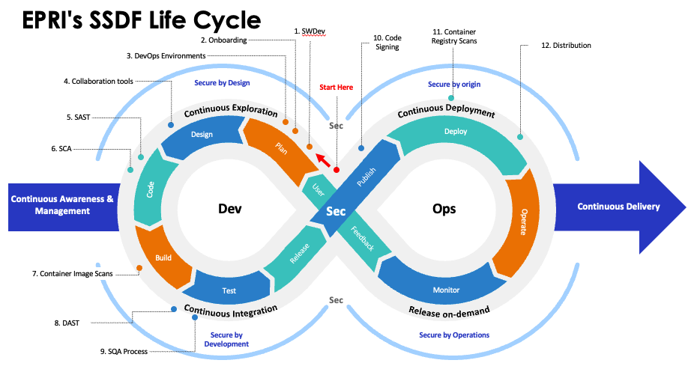

Table of Contents
2025 Software Development Requirements 2
Subscriber Website (SWS) Software Deliverables 2
Desktop Software Deliverables 2
SSDF Playbook Process Cost Estimate 3

2025 Software Development Requirements

Subscriber Website (SWS) Software Deliverables
Review the EPRI Software Development Website (SWDev) for process guidance and product requirements applicable to SWS deliverables. Note the following apply:
- Pipelines: Mandatory for SWS.
- Security scanning: Mandatory per: SSDF SAST & DAST Scan Requirements.
- Source code: Mandatory. Source code must be submitted to the Azure DevOps (ADO) repository along with build instructions, ensuring that the Sector Project Team (R&D PM and developer):
- Can perform the required SAST and SCA scanning with Checkmarx.
- Can build the software using the build instructions.
- Code signing: Not performed at this time but may in the future.
- A Lifecycle plan is strongly recommended (version upgrades, security updates, etc.):
  - Submitted with new software releases.
  - For existing SWS software, submitted when updated.
- Software updates are recommended every 3-5 years (or archival) to avoid obsolescence and minimize security risks (see Sector guidance).

Desktop Software Deliverables
Review the EPRI Software Development Website (SWDev) for process guidance and product requirements applicable to Desktop deliverables. Note the following apply:
- Pipelines: Not mandatory for desktop software; however, an automated build pipeline template is offered and recommended.
- Security scanning: Mandatory per: SSDF SAST & DAST Scan Requirements.
- Source code: Mandatory. Source code must be submitted to the Azure DevOps (ADO) repository along with build instructions, ensuring that the Sector Project Team (R&D Project Manager (PM) and developer):
  - Can perform the required SAST and SCA scanning with Checkmarx.
  - Can build the software using the build instructions.
- Code Signing: Available for Windows by request.
- A Lifecycle plan is strongly recommended (version upgrades, security updates, etc.):
  - Submitted with new software releases.
  - For existing Desktop software, submitted when updated.
- Software updates are recommended every 3-5 years (or archival) to avoid obsolescence and minimize security risks (see Sector guidance).

SSDF Playbook Process Cost Estimate
The Secure Software Development Framework (SSDF) team provides a listing of the expectations for cost and resource requirements, highlighting the costs in 2025 to implement these requirements. The SSDF Cost Estimate document provides budgeting guidance to R&D Project Managers.

