# Developing Computer Based Training



# Articulate Rise Guidelines for Following EPRI Standards

Published: January 13, 2025

Revision 1

## Scope

This job aid will show the process for using the EPRI template for Articulate Rise.

## Intended Users

Instructional Developers creating courses using Articulate Rise that will be hosted on the EPRI Learning Management System.

## Required Resources

This job aid accompanies the following files and explains their usage.

1. EPRI Rise Template (email [Trainingdesign@EPRI.com](mailto:Trainingdesign@EPRI.com) to request a copy)
2. PublishingRise-JobAid.pdf

## Prerequisites

Users need to confirm the following items before executing this job aid.

1. A license to Articulate 360 and access to rise.articulate.com

## Author

Calen Fitzsimmons, Instructional Designer

## Reviewer

Carie Whitehead, Instructional Designer

Tontaleya Moore, Instructional Designer

## Questions

Questions on this job aid should be directed to EPRI’s Training Department at [Trainingdesign@EPRI.com](mailto:Trainingdesign@EPRI.com)

## Revision Summary

1. February 2021 – First publication
2. July 2023 – Updated EPRI Branding template
3. January 2025 – Updated to 2025 copyright.

Table of Contents

Developing Computer Based Training 1

Articulate Rise Guidelines for Following EPRI Standards 1

Scope 1

Intended Users 2

Required Resources 2

Prerequisites 2

Author 2

Reviewer 2

Questions 2

Revision Summary 2

Settings 3

Theme 4

Navigation 4

Title Page 5

Template 5

Standard Lessons 6

Getting Started 6

About This Course 7

Navigating this Course 8

Thank You and Exit Course 9

Publishing 9

## Settings

### Theme

The template has one requirement for theme, which is the EPRI logo. Color, fonts, and Cover Photo are up to the Instructional Designer/Developer. It is recommended that courses designed to be part of a series have a consistent accent color.

|  |  |
| --- | --- |
| 1. The logo used must be the EPRI logo 2. The Cover Photo can be customized to fit the topic of the course. One option is attached to this PDF. |  |

|  |  |
| --- | --- |
| 1. The accent color in the template is the EPRI branding (HEX# **0043c8**). Changing it is up to the developer. 2. The headings and body fonts in the template are Inter. Changing it is up to the developer. |  |

### Navigation

|  |  |
| --- | --- |
| The navigation settings are up to the developer to determine what best fits their needs for the course they are working on.  For example, you can adjust the sidebar to start as collapsed, expanded, or hidden when a learner begins the course. |  |
|  |  |

## Title Page

1. Enter the actual course title into the **2025 EPRI Rise Template** Field
   1. 1.1 Change the Author to *Author Hidden*

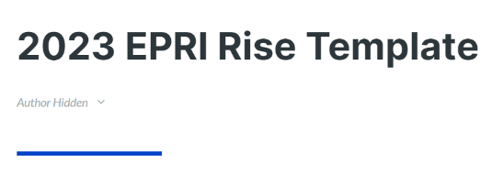

1. A glossary can be included if necessary.
   1. 2.1 If resource links are provided for the course, place them in the resources lesson in the course.
   2. 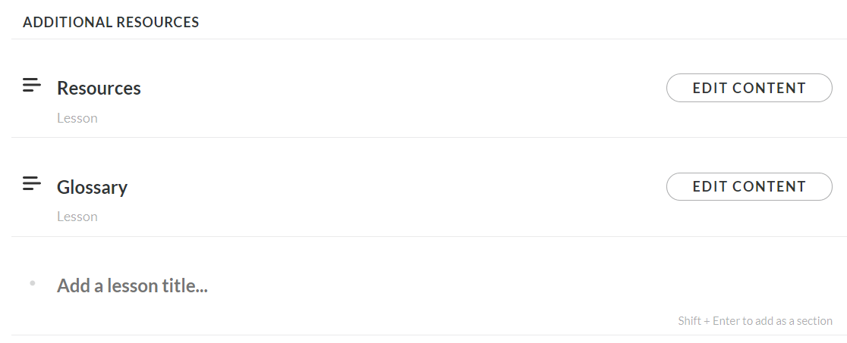
   3. Note: A lesson for a glossary and resources in Articulate Rise is in the template. Delete the Resources and/or Glossary if you do not wish to include them or they do not apply to the course.

## Template

Required lessons including Getting Started, Introduction, and Thank You and Exit Course are provided through the **EPRI Rise Template**.

These templates also include a wide variety of ideas for interactives and multimedia layouts for Articulate Rise. A template for assessments is also provided in the *Assessment* lesson in the Articulate Rise template. Predefined layouts can be used in any course. Developers are encouraged to use different layouts, per the nature of the Articulate Rise product.

When developing, please adhere to the provided template as the core structure, ensuring that any images in the template are replaced accordingly to align with the specific requirements and preferences of the project.

### Standard Lessons

**The following lessons *must* be used in all projects**. All other lessons are optional templates.

* **Getting Started** – see below for modifications
  + **About this Course** – see below for modifications
  + **Navigating This Course -** This is designed so that it does not need modification and fits most courses. Edit if needed.
* **Introduction** – All courses should contain learning objectives. The layout in the *Learning Objectives* lesson of the Articulate Rise template can be used, but no specific design is required.
* **Thank You and Exit Course** – All courses should end with this lesson.

**The following lessons *should* be used in all projects**, but are not required

* **Summary** – Most courses should end by revisiting the learning objectives and summarizing what has been presented. Any layout can be used. This slide is often a duplicate of the *Introduction* lesson with wording modified.

### Getting Started



**This section of the Getting Started lesson must:**

* Contain the exact title of the EPRI Product as shown in SAP (1.). Please get the actual product title from the Project Manager and ask them to update SAP (through their POC) if it is not accurate.
* Have the correct copyright year.
* Use the EPRI logo prominently displayed.

**Optional Features:**

* Background color can be changed as long as it includes the EPRI logo.
* Information on recommended or required prerequisites can be added to this section or a later section in the *Getting Started* lesson.

### About This Course

The following edits should be made.

* Update the **Course Details** tab  
  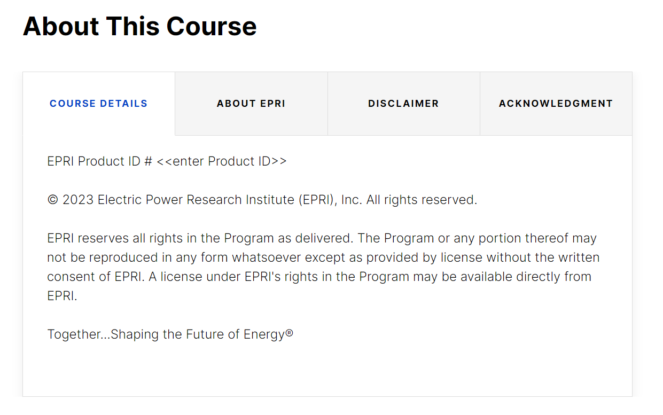

1. Enter the exact course name the Project Manager has in EPRI’s SAP database and the EPRI Product ID #.
2. Verify that the copyright year is correct for the course’s completion and publication date. Update if needed.

* Update the Acknowledgment tab with appropriate information about the people and/or reports you wish to recognize. Delete the report section at the bottom if it is not used. You may display information in a different format on this tab if needed.

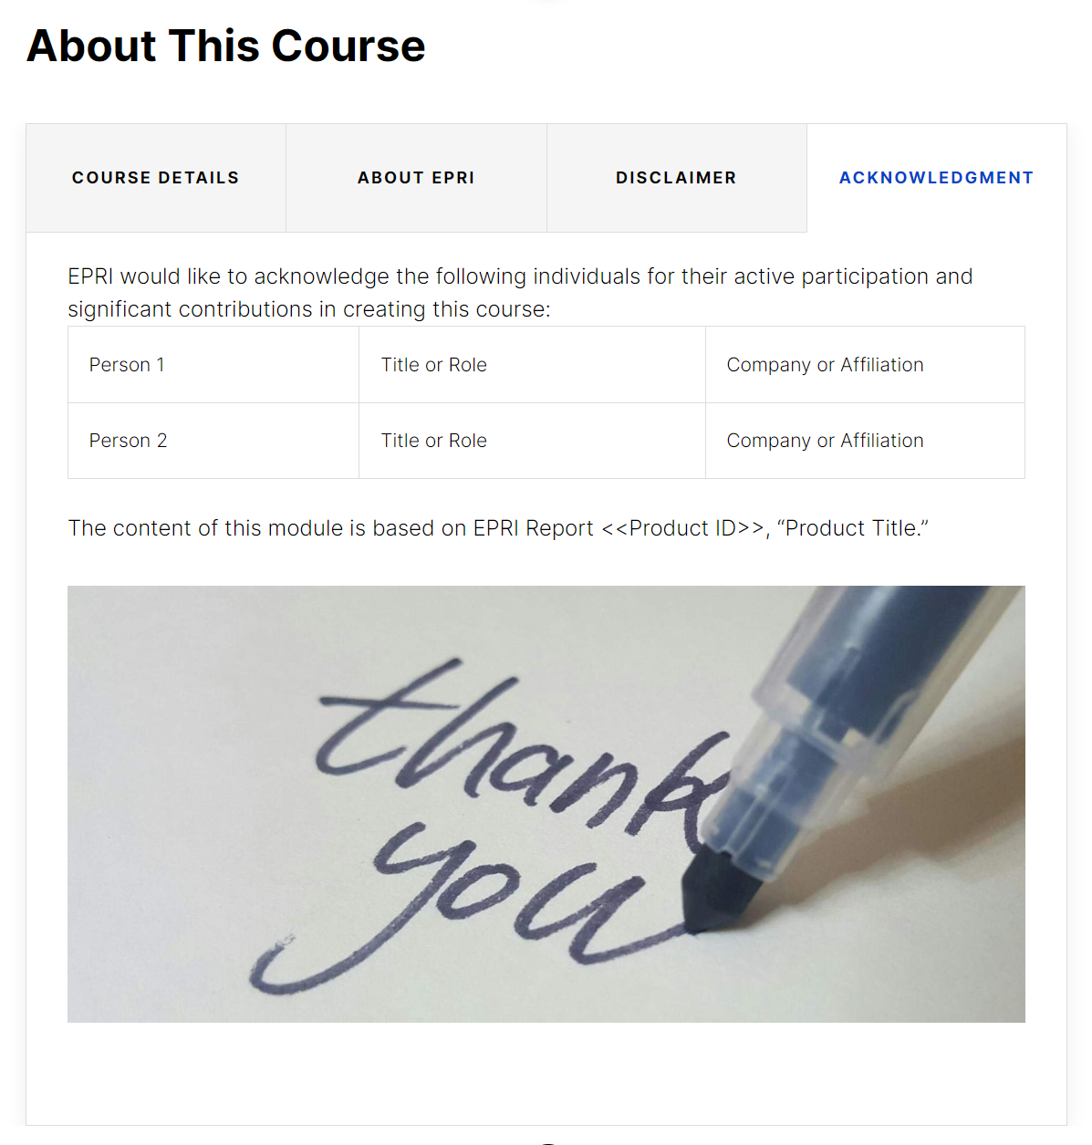

* If there are no Acknowledgments, delete the Acknowledgments tab.

### Navigating this Course

|  |  |
| --- | --- |
| This slide was designed to cover most variations of the player. In most cases, alterations or edits to this slide will not be necessary but use discretion to edit as appropriate for each course. |  |

## Thank You and Exit Course

All courses should conclude with a Thank You lesson. This can be found in the *Thank You and Exit Course lesson* of the template.

|  |  |
| --- | --- |
| * This lesson must be included in all courses. * This lesson must contain the course title, the EPRI graphic, and an Exit button. * The background image and other features can be changed to fit each course. |  |

## Publishing

|  |  |
| --- | --- |
| Publishing guidelines are provided in the document **PublishingRise-JobAid.pdf** and should be followed to ensure compatibility with the EPRI Learning Management System. It is recommended that all course be published in SCORM 2004 3rd edition.  If tracking with “Track using course completion”, do not select 100%. Take the required lesson count and divide it by the total lesson count for the course to get the percentage. |  |